Documentation
Title: Real-Time Healthcare Data Streaming Pipeline using Kafka, Python, and HDFS
Project Name: HealthFlow–Patient Vital Monitoring Pipeline
ABSTRACT
This project presents a real-time data ingestion and processing pipeline for healthcare vitals monitoring. A Kafka producer generates continuous patient data streams, which are validated, transformed, and consumed by a Python Kafka consumer. Finally, the processed records are batched and stored inside the Hadoop Distributed File System (HDFS) using WebHDFS.
This end-to-end pipeline demonstrates real-world data engineering concepts such as stream ingestion, data cleaning, validation, enrichment, and distributed storage. The project replicates how hospitals or IoT healthcare platforms process vital signs in real-time for analytics, alert generation, and long-term storage.
1.INTRODUCTION
Modern healthcare systems continuously generate patient vitals from smart devices, wearables, bedside monitors, and hospital IoT networks. These datasets are real-time, high-velocity, and require immediate processing for anomaly detection and storage for downstream analytics.
1.1 Problem Statement
Traditional systems cannot process thousands of real-time vitals per second. There is a need for a streaming pipeline that can ingest, validate, transform, and store data efficiently.
1.2 Objective
The goal of HealthFlow is to build:
- A real-time data ingestion pipeline using Apache Kafka
- A Python consumer that performs validation and transformation
- A batching system that stores data in HDFS for analysis
- A fully automated and reproducible end-to-end pipeline
2. SYSTEM ARCHITECTURE
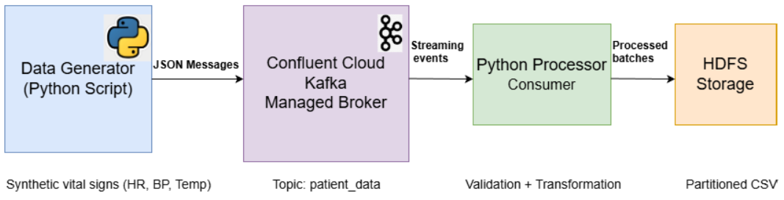

Pipeline Explanation:
Patient vital signs are first generated using a Python script and sent as JSON messages to Kafka (Confluent Cloud). Kafka streams these events in real time to a Python consumer, where the data is validated and transformed. The processed records are then stored in HDFS as date-partitioned CSV files for scalable storage and future analysis.

3. TECHNOLOGY STACK
Component Technology
Streaming Platform Apache Kafka (Confluent Cloud)
Programming Python
Big Data Storage HDFS (Cloudera VM)
Data Access WebHDFS API
Libraries confluent_kafka, pandas, requests
Data Format CSV (batch writing)

4. DATA FLOW DESCRIPTION
4.1 Kafka Producer
A Kafka Producer is an application that publishes (sends) data to a Kafka topic.
A topic is a logical channel where messages are stored.
- Generates patient vitals every 1 second.
- Sends JSON records to Kafka Topic Patient_DataPipeline.
- Fields: patient_id, timestamp, heart_rate, temperature, systolic_bp, diastolic_bp.
  - Kafka Consumer.
A Kafka Consumer is an application that reads (subscribes to) messages from a Kafka topic. The Kafka Consumer reads patient data from Kafka Performs validation, transformation then writes data to HDFS
Consumer Responsibilities:
- Polling data
- JSON decoding
- Validation
- Transformation
- Batching
- Store CSV files in HDFS
Consumer Grouping:
consumer uses: "group.id": "python-consumer-group"
- Allows parallel processing
- Enables fault tolerance
- Kafka remembers which messages are already read
If consumer crashes → it can resume from last offset.

  - Validation

Validation means checking whether the incoming data is correct, complete, and safe to use. In this project, validation ensures that patient vital data makes medical sense before storing it in HDFS.

Validation Rules:
Field | Rule
heart_rate | 30–200
temperature | 35–42°C
systolic_bp | 60–200
astolic_bp | 40–130
  - Transformation Steps
Transformation means modifying the data into a structured, analytics-ready format. Only validated records are transformed.
- Round values
- Add processed_at
- Add ingest_time
- Compute is_high_bp flag
5. HDFS STORAGE
HDFS acts as the central storage layer of the HealthFlow pipeline. It enables:
- Reliable storage of real-time healthcare data
- Distributed and fault-tolerant data management
- Future analytics and reporting

In this project, the processed patient data is stored in HDFS using a date-partitioned directory structure.
/healthflow/patient_data/
└── date=YYYY-MM-DD/
└── patient_data.csv
5.1 Batching System
Batching means collecting multiple Kafka records together and writing them to HDFS as a group, instead of writing each record one by one.
- A batch of 10 transformed records is stored into HDFS as a CSV file.
- Each CSV file contains a batch of validated and transformed patient vital records.

In this project:
- Kafka messages are read continuously
- Records are accumulated in memory
- Once the batch size is reached (10 records), they are written as one CSV file to HDFS
5.2 Partition by Date
Partitioning the data by date is a best practice in big data systems. It provides the following advantages:
- Improve Query Performance
Queries can directly scan only the required date partition instead of the entire dataset.
- Better Data Organization
Each day’s data is stored separately, making it easy to manage, track, and clean historical records.
- Efficient Analytics
Date-based partitions are ideal for tools like Hive, Spark, and Impala, which commonly perform time-series analysis.
- Scalability
As data grows daily, new partitions are automatically created without affecting existing data.
- Easy Maintenance
Old data can be archived or deleted by removing a specific date folder.

6. RESULTS
- Real-time streaming works
- Data validated & enriched
- HDFS storage successful
- Folder-based partitioning implemented
- CSV files available for ML or Spark analytics.
7. USE CASES
This pipeline simulates:
Healthcare Monitoring
- ICU patient monitoring
- Wearable device analytics
- Early detection of high BP events
Big Data Storage
- Long-term patient trends
- Hospital analytics dashboards
Machine Learning
- Predictive patient risk modelling
- Vital anomaly detection

8.CONCLUSION
HealthFlow successfully implements a real-time streaming data pipeline for patient vital monitoring using Kafka, Python, and HDFS. The system handles ingestion, validation, transformation, enrichment, and distributed storage, demonstrating core data engineering concepts. This project forms a foundational architecture for real-world healthcare IoT analytics, ML modelling and hospital alert systems.

